PDIS

By

_________

Level-6

Final Project

Table of Contents

Project Proposal 3

Goals and Objectives 3

Project Scope 3

Project Specifications 3

Target Audience 3

Project Deliverables 4

Resource Requirements 4

Project Tasks and Milestones 4

Project Assumptions 5

Project Report 5

Detail Design 6

Login Page 6

Home Page 6

Employee Home Page 7

Add Department View 7

All Employee View 8

Add Employee Page View 8

View Employee Details  View 9

Employee Salary History View 9

Project Testing 10

User Manual 10

Summary 10

System Configuration 10

User Access Levels 10

# 

# Project Proposal

## Goals and Objectives

The main goal or aim of the project is to implement an online web application named “PDIS”. The main purpose of this web application to build a secure and easily accessible way to manage the employee details and their salary details. HRA has different functionalities as compare to employee of organization. HRA can add, edit, delete and check details of employee and generate their salary according to month year. Employee can access his details in organization database as well as view history of his/her salary.

## Project Scope

The scope of this project is to implement an app named “PDIS” with the help of which view the Employee and their salary management. The duration of the project is 20 working days which is equals to 4 weeks.

## Project Specifications

* HRA login/logout
* Add, edit, delete and check details of Department, allowances and post available inside the organization.
* HRA can delete, edit and check Employee Information available in database.
* HRA can register new HRA.
* Employee and HRA can login/logout.
* Employee can access his/her personal details as well as history of his/her salary.

## Target Audience

The target audience for this project is the people of organization and this web application specific to an organization. The age can go from 18 plus to 100 plus.

## Project Deliverables

The deliverables of the project are:

|  |  |
| --- | --- |
| Deliverable | Description |
| Final Report | This will be the final report of the project. |
| Coding | The executable code of the project will go under this. |
| Documentation | This portrays the documentation of the project. |
| Testing | All the test details will be covered in this part. |

## Resource Requirements

* Windows Operating System.
* Microsoft word for documentation.
* Asp.net MVC Framework
* 64-bit Processor and 4 GB or more RAM
* Identity framework- ASP

## Project Tasks and Milestones

|  |  |  |  |  |
| --- | --- | --- | --- | --- |
| **Tasks** | **Week-1** | **Week-2** | **Week-3** | **Week-4** |
| Brainstorming and analysis |  |  |  |  |
| Planning and initial meeting Project Proposal document. |  |  |  |  |
| Database Design and UI Design |  |  |  |  |
| Identity framework implementation |  |  |  |  |
| Coding for admin and reporter |  |  |  |  |
| Testing |  |  |  |  |
| Final Documentation and closing |  |  |  |  |

## Project Assumptions

Following are the assumption made while implementing the project:

* One HRA and one employee will be registered by default.
* Application will be free and open source.

# Project Report

#### Functional and Non-Functional

|  |  |
| --- | --- |
| Users | Functional |
| HRA | * Login/logout * Register new HRA * HRA can add, edit, delete, check details for department, allowances and post of organization. * HRA can edit, delete and check details for employee of organization available at database. * HRA can generate employee salary and capable of delete them if they wrongly generated |
| Employee | * Can view his/her personal details * Can view his/her history of salary |
|  | Non- Functional |
|  | * High speed * Fast Loading time * High performance and security * All browsers compatibility. |

## Detail Design

### Login Page

The main landing page of the application. Here, user can login with his/her credential to access appropriate content according to their role.

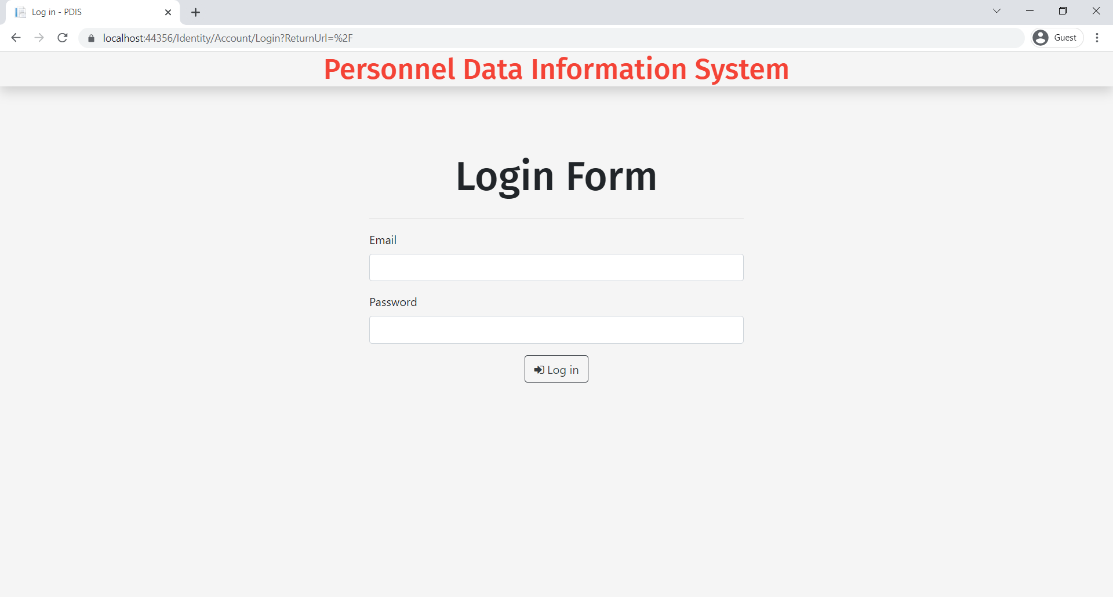

### Home Page

If user is HRA, then, HRA Home Page will appear which provide link of its functionality provided by the web application

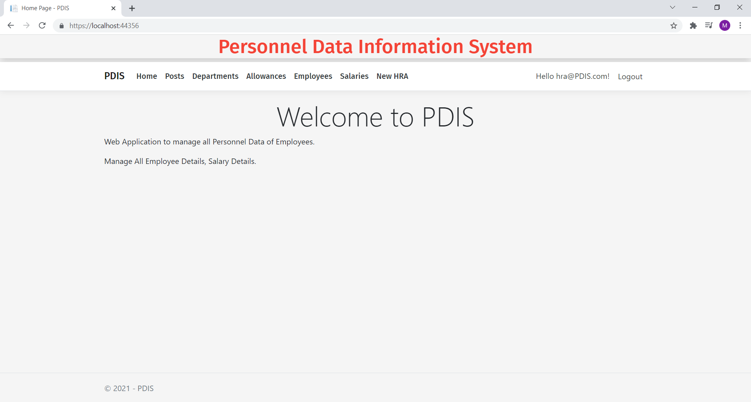

### Employee Home Page

If user is Employee, then, Employee Home Page will appear which provide link of its functionality provided by the web application

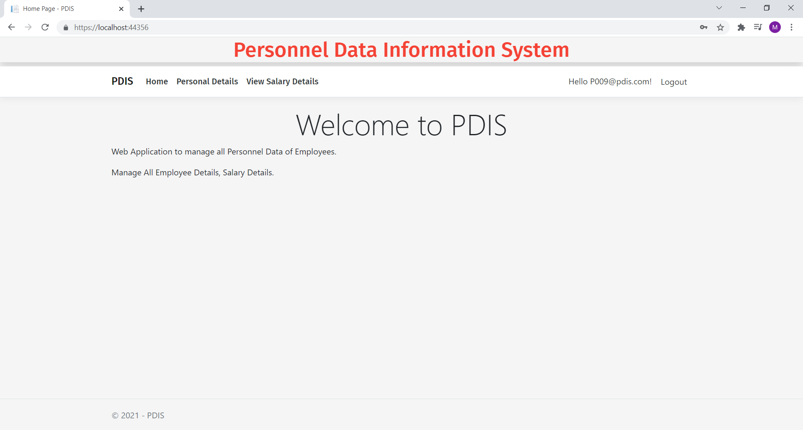

### Add Department View

This page provides a way to add new department of organization.

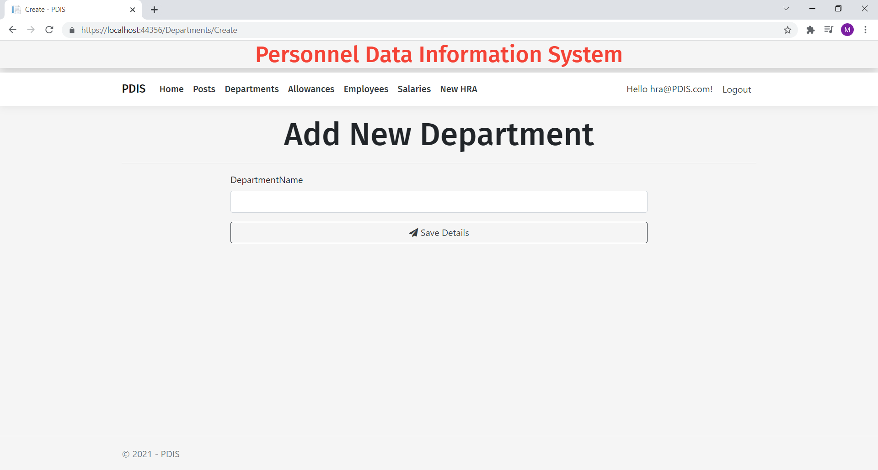

### 

### All Employee View

With the help of this page can view all employee details with their picture.

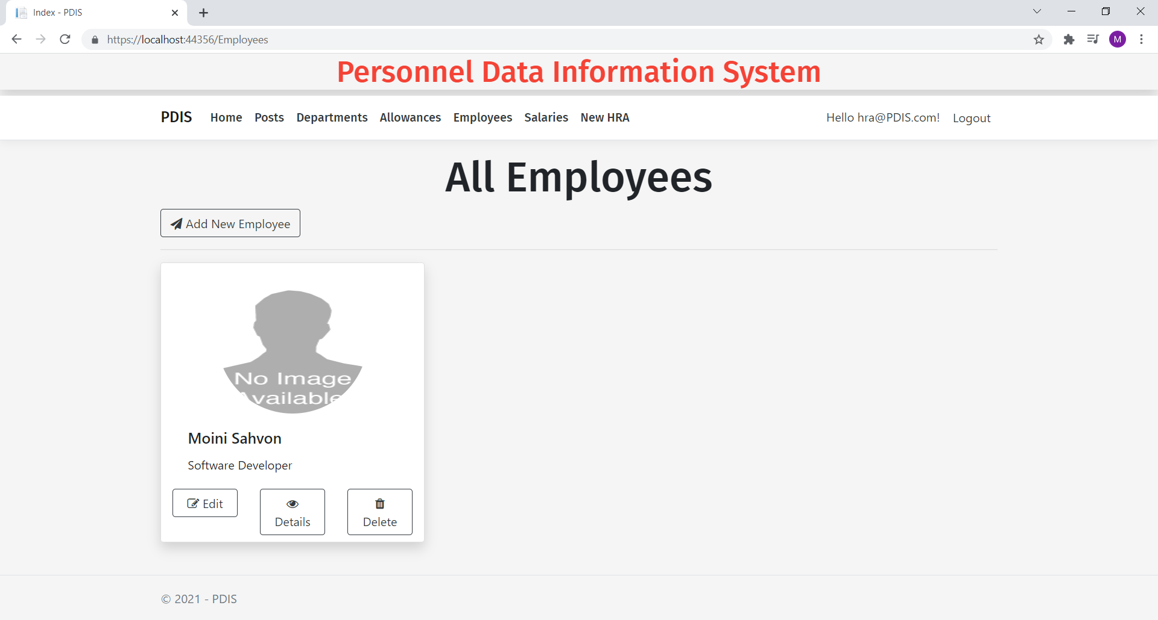

### Add Employee Page View

With the help of this page can add new employee to organization.

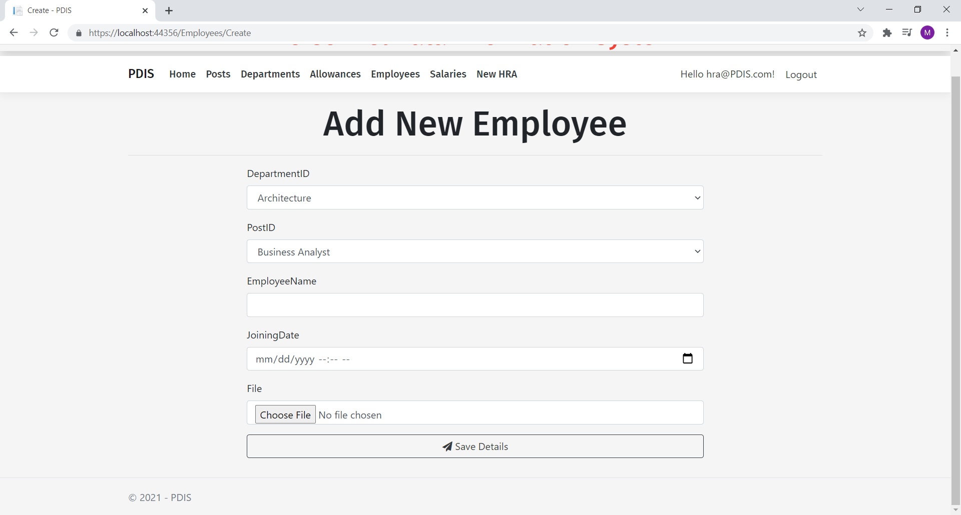

### View Employee Details View

With the help of this page employee can view his/her details store in organization database.

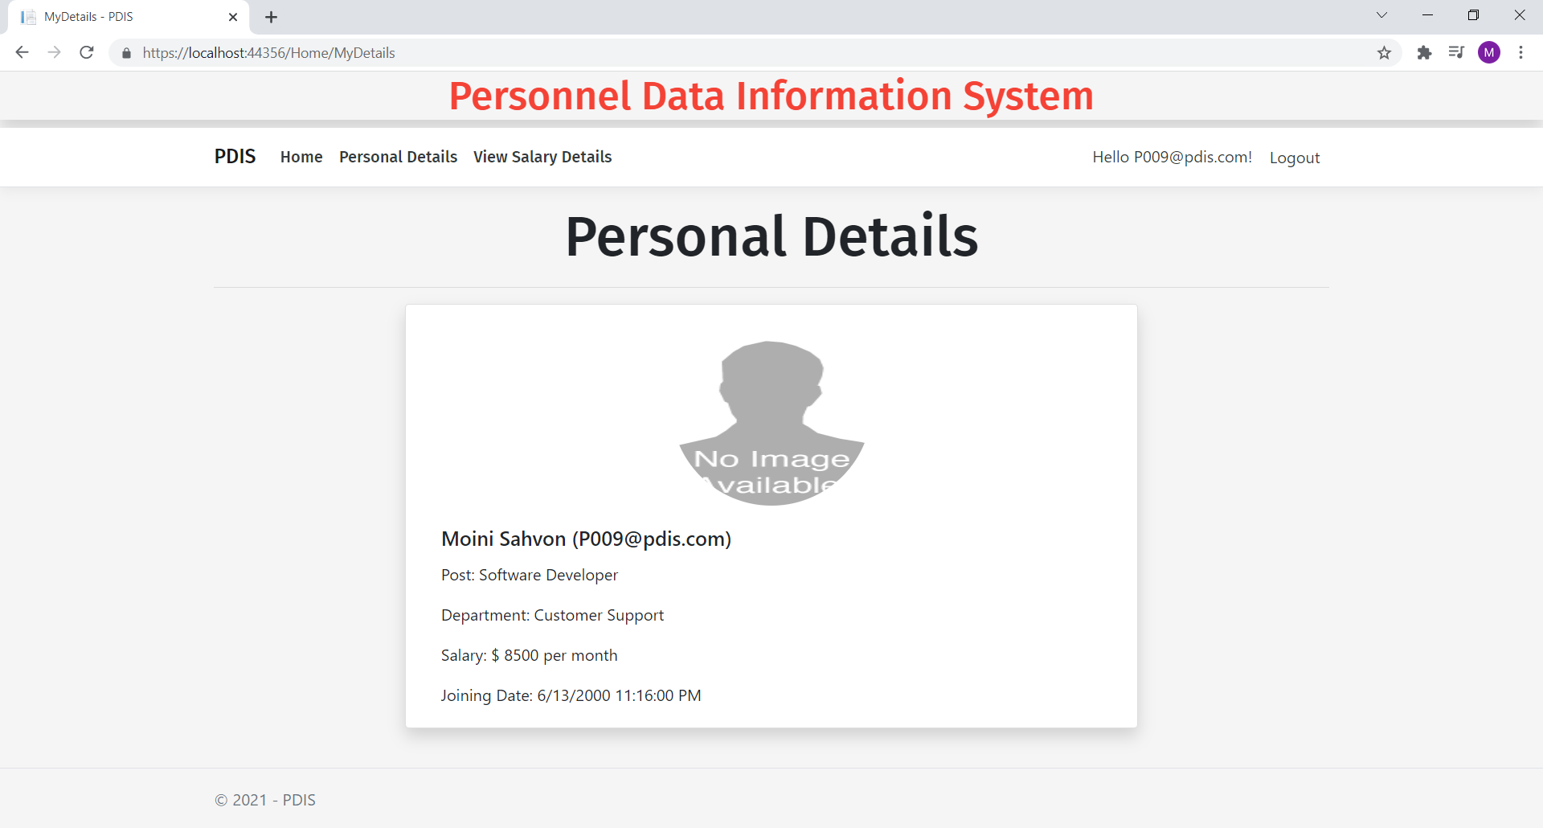

### Employee Salary History View

This page shows the Employee Salary History.

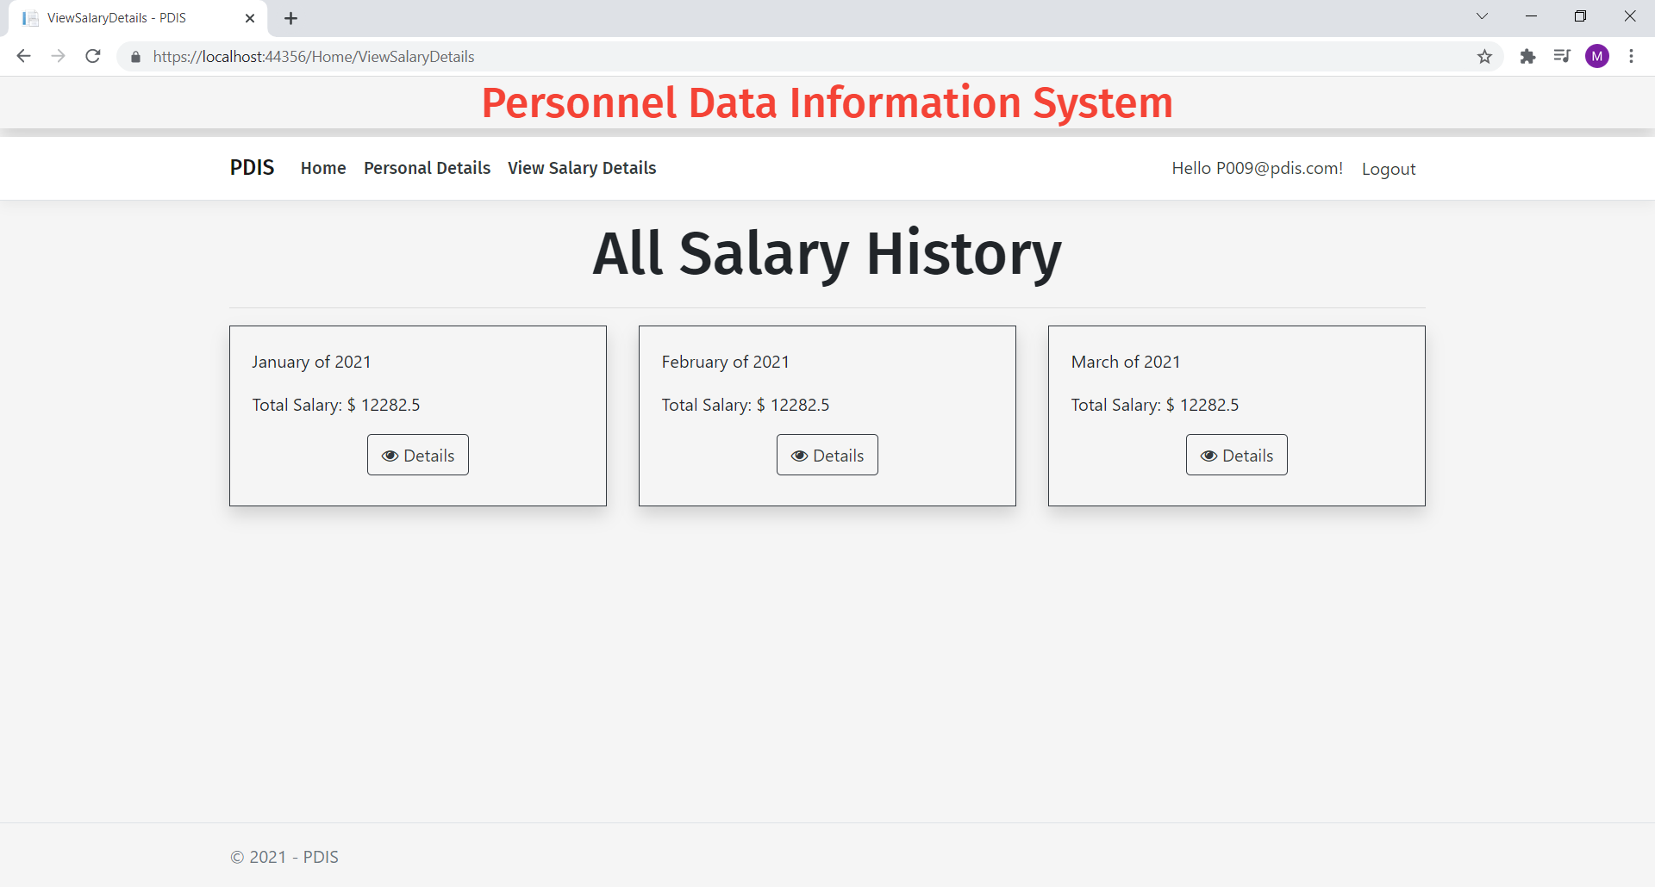

## Project Testing

The testing file for usability testing is attached as [usability test.xlsx](usability%20test.xlsx)

# User Manual

The main purpose of the application PDIS provide a central place for different hr and employee to access their details and salary details. In this application there are two types of users- hr and employee. HRA has different functionalities as compare to registered user. HR can add, edit, delete and check details of employee details and their salary details. Employee user is capable to view his/her personal details as well as salary history.

## Summary

### System Configuration

This app will be useful to for distributing mobile information in presentable format.

### User Access Levels

Only registered users can access the features of this application.

* **HRA:** HRA has full access of the app can register new hr.
* **Employee:** Employee can login using their own credentials. They have limited access.